|  |
| --- |
|  |
| **3104AFE Group Assignment** |
| **NA Group 24** |

**s5092136 Hamdi Abdullahi**

**s5150735 Yuyu sui**

**s5149816 Liyuan Meng**

**s5149724 Zihan Zheng**

**s5150217 Lu Wang**

**GROUP ASSESSMENT COVER SHEET**

Please complete all sections below

Course code: **3104 AFE**

Course name: **Strategic Management Accounting**

Due date: **10/05/2020**

Course Tutor/ convenor: **Shamsun Nahar**

Assessment item #: **2**

Group Participants:

|  |  |
| --- | --- |
| **Student number** | **Student name** |
| **s5092136** | **Hamdi Abdullahi** |
| **s5150735** | **Yuyu sui** |
| **s5149816** | **Liyuan Meng** |
| **s5149724** | **Zihan Zheng** |
| **s5150217** | **Lu Wang** |

**STUDENT CONSENT**

(to be completed by the student before their essay, assignment or other work is uploaded to an internal/online learning University website or used for the purpose of moderation (not to be used if there is to be public access to the Work)

At Griffith the use of assessment exemplars by academic staff is encouraged to inform students’ understanding of the performance standards associated with learning and achievement in the course. An assessment exemplar is an authentic example, actual sample or excerpt, of student work that has been annotated to illustrate the ways in which it demonstrates learning, achievement and quality in relation to the intended learning outcomes (including graduate outcomes) for the course. Assessment exemplars may be made available in a range of ways. In order to collect assessment exemplars students are asked to consent, on every assessment item submitted, for their work, without disclosure of the contributor’s identity, to be used, and reproduced as an assessment exemplar for standard setting and moderation activities.

I acknowledge that for the purpose of standard setting and moderation activities the examiner of this assessment item may wish to store, reproduce, annotate, and communicate my work to others, including future students, without disclosure of my identity.

I consent to my Work, ………………**I Agree**………………………. Without disclosure of my personal details, being stored, reproduced annotated and communicated within the University’s secure online learning environment.

I do not consent to my Work,……………………………………………. being stored, reproduced annotated and communicated within the University’s secure online learning environment under any circumstances.

Acknowledged by: **Hamdi Abdullahi, Yuyu sui, Liyuan Meng, Zihan Zheng, Lu Wang** Date: ……**10/05/2020**…………………

Where the item is submitted electronically Clicking “I Agree” or “I do Not Agree” constitutes an electronic signature for the purpose of student consent.

Griffith University collects, stores and uses personal information for administrative purposes only. The information collected is confidential and will not be disclosed to third parties without your consent, except to meet government, legal or other regulatory requirements. For further information consult the University’s Privacy Plan at

<http://www.griffith.edu.au/about-griffith/plans-publications/griffith-university-privacy-plan>.

Updated: February 2017

**ACADEMIC INTEGRITY DECLARATION**

Breaches of academic integrity (cheating, plagiarism, falsification of data, collusion) seriously compromise student learning, as well as the University’s assessment of the effectiveness of that learning and the academic quality of the University’s awards. All breaches of academic integrity are taken seriously and could result in penalties including failure in the course and exclusion from the University.

Students should be aware that the University uses text-matching software to safeguard the quality of student learning and that your assignment will be checked using this software.

I acknowledge and agree that the examiner of this assessment item may, for the purpose of marking this assessment item:

☒ reproduce this assessment item and provide a copy to another Griffith staff member; and/

☒ submit this assessment item to a text-matching service. This web-based service will retain a copy of this assessment item for checking the work of other students, but will not reproduce it in any form.

Examiners will only award marks for work within this assignment that is your own original work. I, hereby certify that:

☒ except where I have indicated, this assignment is my own work, based on my personal study and/or research.

☒ I have acknowledged all materials and sources used in the preparation of this assignment whether they be books, articles, reports, lecture notes, or any other kind of document or personal communication.

☒ I have not colluded with another student or person in the production of this assessment item unless group work and collaboration is an expectation of the assessment item.

☒ this assignment has not been submitted for assessment in any other course at Griifith, or at any other University or at any other time in the same course without the permission of the relevant Course Convenor.

☒ I have not copied in part or in whole or otherwise plagiarised the work of other students and/or other persons.

☒ I haven’t made this piece of work available to another student without the permission of the Course Convenor.

Providing this declaration falsely is considered a breach of academic integrity. I have retained a copy of this assessment item for my own records.

Acknowledged by: **Hamdi Abdullahi, Yuyu sui, Liyuan Meng, Zihan Zheng, Lu Wang**……………………………………. Date……**05/10/2020**…………………………….

Where the item is submitted electronically Clicking “I Agree” constitutes an electronic signature for the purpose of assignment declaration compliance.

Extension Requests: Assessment Item Number:

Extension Granted: ☐ Y ☐ N Extension Approved by:

Due Date:

Amended Due Date:

Approval Date:

Examiner’s Use Only: Name:

Mark Given:

Second Examiner:

(if required)

Mark Given:

Tick Where Appropriate:

☐ Submitted late without extension – returned to student to seek extension /special assessment.

☐ Suspected plagiarism: referred to the Course Convenor.

☐ Returned to student to be resubmitted by:

(date) for the following reasons:

Examiner’s Comments:

Griffith University collects, stores and uses personal information for administrative purposes only. The information collected is confidential and will not be disclosed to third parties without your consent, except to meet government, legal or other regulatory requirements. For further information consult the University’s Privacy Plan at

<http://www.griffith.edu.au/about-griffith/plans-publications/griffith-university-privacy-plan>.

Updated: February 2017

|  |  |  |  |
| --- | --- | --- | --- |
| **WORK CONTRIBUTION FORM** | | | |
| **Group # ……24……… Campus …Nathan…………** | | | |
| **Std ID** | **Name** | **Percentage of contribution** | **Signature** |
| **s5092136** | **Hamdi Abdullahi** | **20%** | **Hamdi** |
| **s5150735** | **Yuyu sui** | **20%** | **Yuyu sui** |
| **s5149816** | **Liyuan Meng** | **20%** | **Liyuan Meng** |
| **s5149724** | **Zihan Zheng** | **20%** | **Zihan Zheng** |
| **s5150217** | **Lu Wang** | **20%** | **Lu Wang** |

**Contents**

1 Introduction 6

2 Proposed balanced scorecard design 6

**2.1 Keendy Brew’s vision and strategy 6**

**2.2 Balanced Scorecard Perspective 6**

**2.2.1 The strengths and weaknesses of the measures implemented in the four aspects of the balanced scorecard 6**

**2.2.2 Reach a conclusion about the reasonableness of the set of balanced scorecard measures for that perspective 7**

**2.3 Pros and cons of implementing a balanced scorecard 8**

**2.4 The value of a balanced scorecard to the managers of Keendy Brew 9**

3 Recommendation whether Keendy brews should adopt a balanced scorecard 10

4 Conclusion 10

5 Reference List 11

# **1 Introduction**

This report will analyze the balanced scorecard in the case of Keendy Brew and indicate whether the company is recommended to use the balanced scorecard.

# **2 Proposed balanced scorecard design**

## **2.1 Keendy Brew’s vision and strategy**

Keendy Brew’s vision is to proudly produce and sell extraordinary fresh, healthy and delicious soft drinks to satisfy kids of all ages. The organization's objective is to expand the business to other geographic regions and maintain its product quality with the sustainable development of the company.

## **2.2 Balanced Scorecard Perspective**

### **2.2.1 The strengths and weaknesses of the measures implemented in the four aspects of the balanced scorecard**

**Financial Perspective:** The advantage of the company's implementation of the manufacturing cost analysis for each case is that it allows the company to fully understand the proportion of expenses incurred in production and make some adjustments. The operating profit and return on investment of each case are lag indicators, which are an assessment of the company's current profitability and capital utilization rate. However, these measures do not indicate the company's future sustainable profits, cash liquidity and return on investment.

**Customer Perspective:** Meeting customer needs is the key to increasing profits. The advantage of implementing the lead indicators of the number of complaints, quality index, and sales growth percentage is that the company uses this information to improve product quality and predict customer preferences for products, thereby capturing improved lag indicators from this perspective. However, because the company lacks lag indicator design such as customer satisfaction and market share, these measures are not conducive to the company's measurement of the results of the business it has already carried out.

**Internal Business Process Perspective:** This perspective is to meet the goals of the customer perspective to improve the company's financial situation. The measures of lag indicators of the production time ratio, throughput and waste ratio are the conclusions made by the company on the original basis to improve the manufacturing aspect, which helps the company to adjust the product quality and production process. However, the disadvantages are that the company's neglect of other business impacts leads to failure to meet the goals of the customer's perspective, nor does it use innovation to design new operational processes.

**Learning and Growth Perspective:** The purpose of this perspective is to provide infrastructure for the other three perspectives to narrow the gap. Collecting accurate data on the number of work-related injuries is a lag goal that helps companies improve production equipment. However, the company cannot judge employee satisfaction based on a single aspect. The benefit of implementing the lead indicators of employee training time and volunteer time is that companies can design training time to develop employees’ technical skills, thereby narrowing the gap with business process objectives. Also, employees who are volunteers can help them better understand customer preferences, thereby narrowing the gap between customer perspectives and goals. However, these measures are not conducive to the control of training quality.

### **2.2.2 Reach a conclusion about the reasonableness of the set of balanced scorecard measures for that perspective**

**Financial Perspective:** Keendy Brew analyzes the profits of each box of products from a financial perspective. It increases the profit of its products by reducing the manufacturing cost. At the same time, increasing the return on investment also increase the profit.

**Customer Perspective:** In the customer perspective, Keendy Brew needs to increase its return on investment by increasing the percentage sales growth, so it collects feedback, what advice and ideas the customers have on the taste, freshness and packaging of the drink and beer. The quality of the beverages also needs to be ensured to be qualified, whether from the beginning of the factory production to the later service. There are measures that can be increased by percentage sales growth. These practices are designed to increase customer satisfaction and increase profits.

**Internal Process Perspective:** From internal business process perspective, Keendy Brew summarizes the ratio of factory production time to total available time, and thus summarizes how to improve the efficiency of plant production, which can reduce production costs. Statistics the number of product packaging, can reasonably speed up production, improve efficiency. Statistics of factory waste as a percentage of production costs, Keendy Brew can understand the amount of waste produced, reasonable reduction of waste generation, reduce production costs and increase profits.

**Learning and Growth Perspective:** From learning and growth perspective, Keendy Brew understands the number of injuries, reducing the number of injuries can reduce costs. At the same time, Keendy Brew also calculated the training time of employees, through training can make employees get more knowledge, work in more efficient, improve the efficiency of factory production, thereby reducing production costs. Employees' time as volunteers allows employees to spend more time and experience reaching out to customers. As a result, employees may have a better understanding of customer needs.

Therefore, through analyzing Keendy Brew's measures from four perspectives, the company can achieve the ultimate goal of increasing product profits and sustainable long-term development.

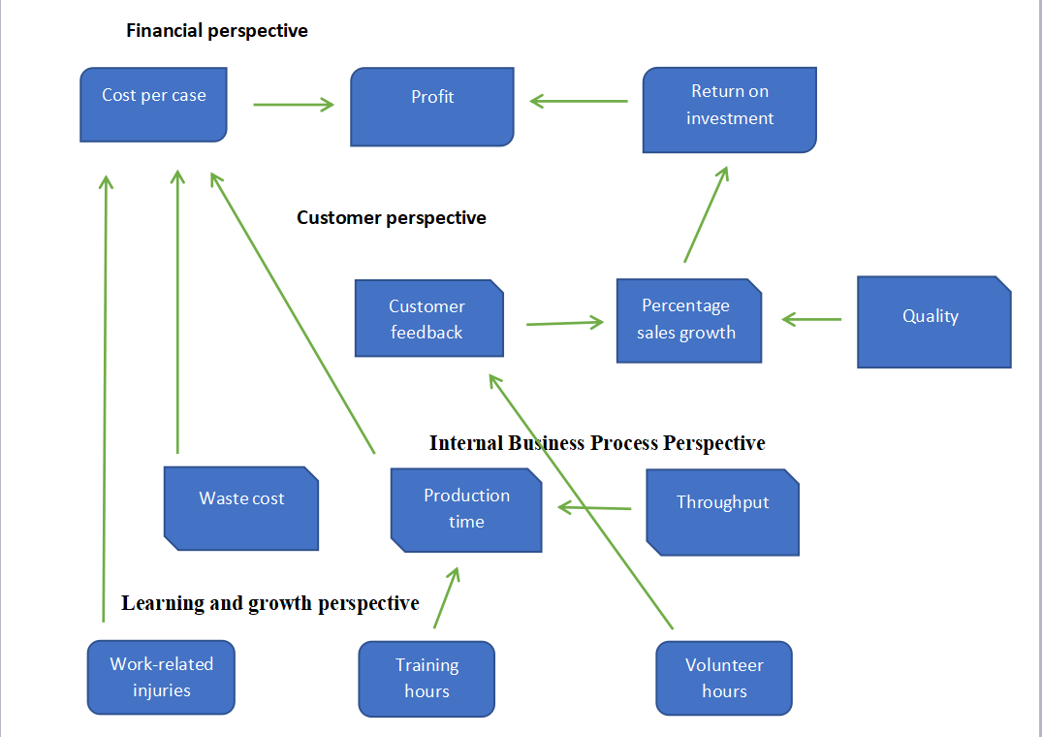

## **2.3 Pros and cons of implementing a balanced scorecard**

A distinguishing feature of the balanced scorecard is that it can identify financial and non-financial indicators covering different perspectives, thus providing a way to translate strategies into actions (Sainaghi, Phillips & Corti, 2013). Besides, the balanced scorecard provides a clear and intuitive framework for organizations to measure performance standards (Massingham, Massingham & Dumay, 2019). As a systematic methodological work, the balanced scorecard explains the organization's mission and strategic goals in a visual form, and how to achieve these missions and goals. This is more conducive to the company's management and internal employees to understand the organization's performance measurement standards and whether to achieve these four aspects goals (including financial perspective, customer perspective, international business process, and learning and growth).

Although the balanced score table as a strategic planning tool can effectively measure company performance, its implementation still has many shortcomings. For small and medium-sized enterprises the use of balanced scorecards has huge limitations in terms of time, organization, and money (Zizlavsky, 2014). The company needs to hire professionals who understand the working principle of the balanced scorecard and can use it correctly, which requires a cost. At the same time, the company also should train employees to understand how balanced scorecard work so that they can monitor and track the entire team, which will take a certain amount of time. In addition, the balanced scorecard contains limited information. The balanced scorecard ignores the time dimension. The business environment will continue to change with time, so the balanced scorecard also needs to regularly adjust specific goals and strategies to adapt to changes in the environment.

## **2.4 The value of a balanced scorecard to the managers of Keendy Brew**

If Keendy Brew wants to use the balanced scorecard to successfully achieve its business goals, it must first clarify the company's mission, overall goals and strategic priorities (Busco & Quattrone, 2015). Managers of Keendy Brew must understand the company's goals in order to successfully communicate its strategy and expand its business to other regions. Also, the entity must ensure that plans and activities are carried out throughout the organization, so that the entity can better achieve their goals.

Managers also need to set detailed goals for each perspective. According to the case, managers have developed three plans for each perspective. Therefore, to achieve the overall goals of the enterprise, these measures must be strictly implemented. Besides, managers can also use the form of strategy maps. The strategy map can be used to more clearly express the cause and effect relationship and combine the BSC's perspective and organizational goals (Okongwu, Brulhart & Moncef, 2015; Massingham, Massingham & Dumay, 2019). Drawing the four aspects of financial, customer, internal business and learning and growth perspectives into a strategy map can clearly convey Keendy Brew's strategic information to managers and help implement the strategy.

Setting goals for performance indicators is also a good way to motivate employees and managers to work hard, such as setting leading indicators (Perramon, Rocafort, Bagur-Femenias & Llach, 2016). Favorable leading indicator measures will encourage employees to work hard and achieve their goals. It also helps managers make wise decisions. This will reinforce Keendy Brew's vision.

Also, managers can delegate the balanced scorecard to each department or manager. Doing so can align the goals of the organization with the goals in the balanced scorecard, and enable managers in all regions to more accurately determine their scope of work (Arasli, Alphun & Arici, 2019). Managers should also regularly develop reports to regulate and manage the performance of the operations of various departments and regions, and compare with the goals set on the assigned balanced scorecard to improve the overall performance of the enterprise.

# **3 Recommendation whether Keendy brews should adopt a balanced scorecard**

Its recommended that Keendy adapts a balanced scorecard approach to better achieve all the set perspectives. The basis of this recommendation is that a balanced scorecard provides a powerful framework to communicate and develop strategy. The balanced scorecard strategic map helps managers visualize and process the relationship between various strategic objectives to ensure strategic objectives are achieved. Additionally, the strategic map allows the organization to effortlessly communicate the strategy to both external and internal parties. It would be difficult for Keendy to achieve strategy if he does not fully understand it, thus making strategic map essential because it simplifies and visualizes strategic objectives clearly.

Another reason for Keendy to adapt a balanced scorecard approach is that it leads to a better cascading and organizational alignment. This is because in order to achieve strategic objectives, organization must ensure that all 4 perspectives are working towards the same goal. Therefore, through the implementation of balanced scorecard framework, the top-level strategy can easily be cascaded to the lower levels. This gives top management a better idea on how the strategy is executed.

# **4 Conclusion**

Overall, this report discusses the strengths and weakness of the four perspectives of the balanced scorecard made by Keendy Brew based on the analysis of the company’s vision and strategy, and draws a strategy map to support the conclusion about the reasonableness of the set of balanced scorecard measures. In addition, the pros and cons of a balanced scorecard are analyzed. Finally, it suggests that Keendy Brew should implement and optimize the balanced scorecard to help the management better realize company’s vision.

# **5 Reference List**

Arasli, H., Alphun, C., & Arici, H. E. (2019). Can balanced scorecard adoption mediate the impacts of environmental uncertainty on hotel performance? the moderating role of organizational decision-making structure. *Journal of Hospitality Marketing & Management, 28*(8), 981-1009. doi:10.1080/19368623.2019.1578716

Busco, C., & Quattrone, P. (2015). Exploring how the balanced scorecard engages and unfolds: Articulating the visual power of accounting inscriptions. *Contemporary Accounting Research, 32*(3), 1236-1262. doi:10.1111/1911-3846.12105

Massingham, R., Massingham, P. R., & Dumay, J. (2019). Improving integrated reporting: A new learning and growth perspective for the balanced scorecard. *Journal of Intellectual Capital, 20*(1), 60-82. doi:10.1108/JIC-06-2018-0095

Okongwu, U., Brulhart, F., & Moncef, B. (2015). Causal linkages between supply chain management practices and performance: A balanced scorecard strategy map perspective. *Journal of Manufacturing Technology Management, 26*(5), 678-702. doi:10.1108/JMTM-01-2013-0002

Perramon, J., Rocafort, A., Bagur-Femenias, L., & Llach, J. (2016). Learning to create value through the 'balanced scorecard' model: An empirical study. *Total Quality Management & Business Excellence, 27*(9-10), 1121-1139. doi:10.1080/14783363.2015.1060853

Sainaghi, R., Phillips, P., & Corti, V. (2013). Measuring hotel performance: Using a balanced scorecard perspectives’ approach. *International Journal of Hospitality Management, 34*(1), 150-159. doi:10.1016/j.ijhm.2013.02.008

Zizlavsky, O. (2014). The balanced scorecard: Innovative performance measurement and management control system. *Journal of Technology Management and Innovation, 9*(3), 210-222. doi:10.4067/S0718-27242014000300016